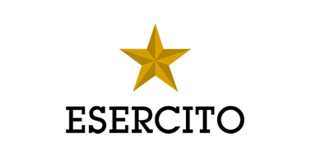
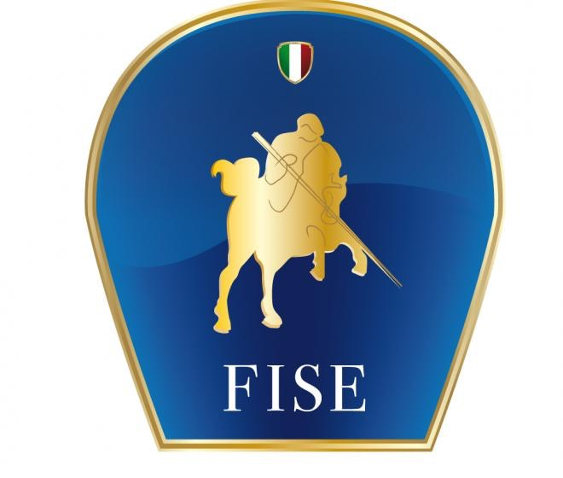
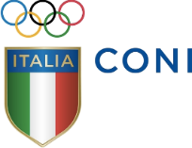
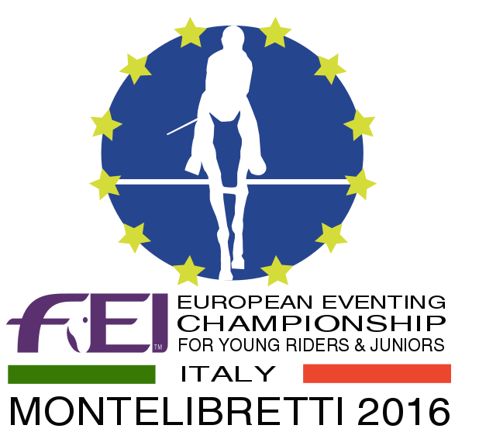

FEI European Eventing Championship
for Young Riders & Juniors 2016 - Presented By Saudi Airlines

Press Release n. 7
Equestrian, Eventing
The junior italian team for the continental challenge

Jacopo Comelli, selector of the Italian junior team, has announced which riders will represent their country at the FEI European Eventing Championship for Young Riders & Juniors 2016 - Presented By Saudia (21/25 settembre).
The following athletes and their horses will take part in the continental challenge hosted by the Military Equestrian Centre of Montelibretti:
Margherita Bonaccorsi (Button Clover) - P.C. Athlion-Sabina; Lavinia Brogi (Fernhill Chivas) - ll Dragoncello; Francesco De Angelis Corvi (Dunbeggin lmp) - P.C. Athlion-Sabina; Maria Sole Girardi (Hero Motivator) - Scuderia C&G; Filippo Gregoroni (Drop of Jupiter/Lefuria) - Podere Torre; Alice Luciani (Sam B) - Scuderia C&G; Ginevra Maffezzoli (Ballygannon Orbis Lad) - Scuderie Prato Basso; Clara Mayer (Stonehavens Master Class) - Podere Torre; Allegra Ragaini (Athina Quandolyn) - Scuderia C&G; Carolina Silvestri (Dutchdaleo Z) - ll Dragoncello; Lorenza Trombini (Qado D'Argonne) - C.l.Ravennate; Elisa Vincenti (Herminia) – Il Dragoncello.
Reserves are: Leonardo Lo Faso (Millenium Mission) - P.C. Athlion-Sabina, Gaia Mazzocchi (Quenji De Beny) - P.C. Montevecchio.

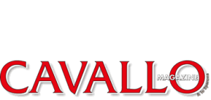
The twelve juniors and the twelve young riders who will compete for Italy are currently team training in Pratoni del Vivaro. Some of them are students of Stefano Brecciaroli and of the Roman riding school and so one can still breathe some of the Olympic excitement.

